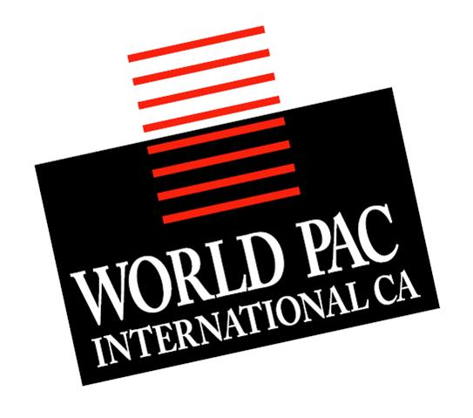

Product specification
Sun Net
Netting size information:
Net size: 18- R- 5
Size 18, square 2.5 cm X 1,5 cm
50 metres per roll – 10 rolls per case
Country of origin: Malaysia
All rubber thread used in production is only from Malaysian origin.
All yarns used for production is from Malaysian, South Korean or Taiwanese origin. No raw material from Chinese origin is used in our products.
Composition of netting: cotton, rubber
Maximum cooking temperature: 150 degree Celsius.
CFIA approval date: 09-09-2011

World Pac Int. Canada 220 Broad st. E suite 116 Dunnville , On NA1 1G2
September 2011 Sun Net specifiations

